Daniel Fryer
Assignment Mod-1
1/14/2026

Repository URL:
https://github.com/XcitedMonkie/csd-325.git

Git repository screenshot:
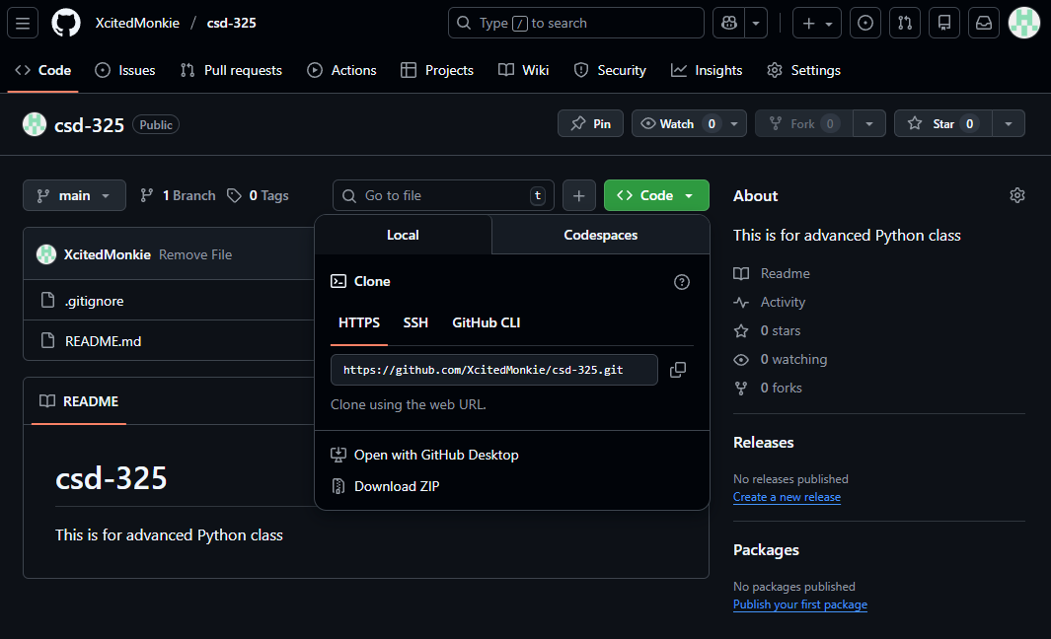

Local directory screenshot:
